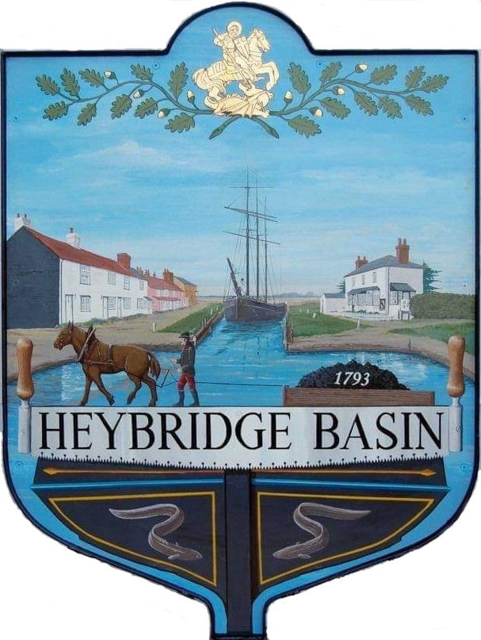

HEYBRIDGE BASIN PARISH COUNCIL

Minutes of the Full Council meeting of Heybridge Basin Parish Council held on Tuesday 18th June 2024 at 06:30pm, at The Lock Tearoom.

PRESENT

In the Chair: M. Hodges (Chair) Absent: 0

Councillors: R. Bryson (Vice Chair) Apologies: 1
C. Swann
G. Howat
M. Hobden Public: 3
J. Sjollema
Officers: G. Lake – Clerk

It was noted that this meeting was being recorded by the Clerk.

24/026 Chair’s Welcome.
The Chair opened the meeting by thanking Councillors and volunteers for their hard work for the D-Day 80 event and stated that lots of positive feedback had been received. The Chair reminded members that they hold collective responsibility as members of the Council.

24/027 To note apologies for absence.
Cllr Edmond.

24/028 To receive Declarations of Interest in accordance with the Council’s Code of Conduct and with section 106 of the Local Government Finance Act 1992.
Cllr Hobden – Non-Pecuniary – HBSA, Basin Oars and HB River care and Cllr Swann - Non-Pecuniary - Owner of Tearoom building. Cllr Howat - Non-Pecuniary – HBCSA.

24/029 To sign as a correct record the minutes of the annual statutory meeting held on 20th May 2024.
The Minutes as previously circulated were agreed as a correct record.

24/030 To receive a report from:
- District Councillors - A report was received and circulated from the District Councillors.
- County Councillor – There was no report from Cllr Durham.
- Essex Association of Local Councils (EALC) Representative – Cllr Hafiz sent his apologies.
- Heybridge Basin Neighbourhood Watch – K. Wood gave a verbal report outlining the background of the village Neighbourhood Watch Group and what the group does. If anyone would like to join the group, they can contact Karen Wood, or the Clerk who can pass on Karen’s details.

Cllr Sjollema arrived at 18:39
1 member of public left.

The Chair announced that Item 11 – Daisy Meadow Car Park (DMCP) would be moved to proceed Item 6 – Finance as per Standing Order 2a.
24/031 DMCP
- To receive an update from the Working Group and agree any action to be taken.
The cost of the Haydn Evans sign off visit came back as more than previously agreed. It was resolved to accept the cost of £2,325 plus VAT which includes a topographical survey.
It was resolved to amend Camways second invoice to £20,000.00 in order for the Council to retain funds until Haydn Evans have signed off the work.

The planting budget currently has £200.00 from a donation. It was resolved to add £300.00 to the budget with Cllr Hobden purchasing plants when required.

It was noted that the Internal Auditor states that Smart Parking must provide the income information requested, otherwise the Council are unable to continue their contract with them.

24/032 Finance.
- To approve
- Payment requests for May/June 2024
The Payment requests as previously circulated were approved with the condition of amending the payment to Camway to £20,000.00.
- Receipts for May/June 2024
The receipts as previously circulated were approved.
- To discuss the Councils Reserves and agree any action to be taken.
The Council currently have £17,000.00 in General Reserves. It was resolved to increase the General Reserves to £26,000.00 by the end of the financial year to reflect the Council’s expenditure, exclusive of major projects.

24/033 Annual return for the year ending 31st March 2023
  - To approve and sign the Annual Governance Statement (Section 1) of the Annual Governance and Accountability Return (AGAR) for 2023/24
The Annual Governance Statements (Section 1) of the AGAR for 2023/24 were approved and signed.
  - To approve and sign the Accounting Statements (Section 2) of the AGAR for 2023/24.
The Accounting Statements (Section 2) of the AGAR for 2023/24 were approved and signed.
  - To note and approve the Internal Audit Report from April Skies Ltd for 2023/24.
The Internal Audit Report from April Skies Ltd for the 2023/24 financial year as previously circulated was noted and approved.
  - To approve date of inspection by Electors.
It was resolved that the date of inspection by Electors would be Monday 24th June to Friday 2nd August 2024.

24/033 Personnel Committee
  - To confirm the committee members and agree any action to be taken.
It was resolved that Cllr Howat would be appointed to the Personnel Committee.
  - To approve the Terms of Reference.
It was resolved to approve the Terms of Reference.

24/034 Training
- To consider registering members onto any relevant training courses.
It was resolved that Cllr Hobden would attend the 2-day Councillor training Course. Clerk to book.

24/035 Planning Applications
- To consider any planning applications received after the publication of the agenda and to agree the action to be taken.
There were no planning applications.

24/036 Goal Posts/Basketball hoops
  - To receive an update from the Clerk and agree any action to be taken.
An update from the Clerk was received. It was resolved for the Clerk to contact Mr Riches regarding volunteering as the Council’s Health and Safety volunteer. It was resolved for the Clerk to re-apply for funding towards the goal posts. It was resolved for the Clerk to request a quote from HRS Marine Services regarding netball hoop installation and mat cleaning costs. Cllr Swann abstained from the vote.

24/037 D-Day 80
- To receive an update from the Working Group and agree any action to be taken.
The Working Group confirmed that a total of £330.42 was raised at the event plus any donations made through the QR Code. It resolved to donate the opened sweets and Chocolate to the Regatta Committee and the pens, cotton reels, straws, quizzes and colouring pages to Heybridge Primary School. It was resolved for the Clerk to write a letter of thanks to all volunteers and groups in the village that assisted with the event and gift them a commemorative coin.
- To disband the Working Group.
It was resolved to disband the Working Group.

24/038 Correspondence
- To note correspondence received and consider any actions to be taken.
Correspondence was noted and responses were agreed.
It was resolved for the Clerk to complete the application for Salt Bags from Essex Highways. Cllr Swann will store the Salt Bags on behalf of the Council.
It was resolved for the Clerk to purchase an Air Up Bottle and Pods as a donation for Heybridge Primary School PTFA.

24/039 Pursuant to section 1(2) of the Public Bodies (Admission to Meetings) Act 1960 it is resolved that, in view of the confidential nature of the business about to be transacted, it is advisable in the public interest that the press and the public be excluded, and they are instructed to withdraw.

Members of the public left.
It was resolved to extend the meeting until close of business.

24/040 Formal Complaint
- To receive a report from the Clerk and agree any action to be taken including a formal response.
A formal complaint was received regarding the Leanna House planning application and how the Council dealt with it as well as the decision change. A report was received and circulated by the Clerk outlining details of the complaint, a timeline of events as well as advice from the various officers and advisors the Clerk had contacted.

The Council held a lengthy discussion regarding the matter. It was resolved to use the information from the Clerk’s report to respond to the legal matters raised, and for Cllr Hodges to draft a response in relation to the perception the Council’s actions had given.

There being no further business the meeting closed at 08:55pm
Provisional Date of the next Council Meeting Tuesday 16th July 2024

Clerk Contact details: clerk@heybridgebasinpc.org.uk
Website: www.heybridgebasin-pc.gov.uk

